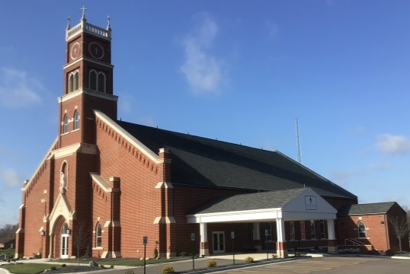

St Mary Parish 2021-2022 Religious Education Calendar Class Times:
Middle School: 6:00 - 7:00 & High school: 7:15 – 8:15
September 15 | First Class – Opening Mass @6:00
September 22 | Class –
September 29 | Class –
October 6 | Class –
October 13 | Class -
October 20 | No Class – Fall Break
October 27 | Class –
November 3 | Class –
November 10 | Class –
November 17 | Class -
November 24 | No Class – Thanksgiving Break
December 1 | Class –
December 8 | Immaculate Conception - Mass @6:00
December 15 | Class –
December 22 & 29 | No Class – Christmas Break
January 5 | Class -
January 12 | Class -
January 19 | Class –
January 26 | Class –
February 2 | Class –
February 9 | Class -
February 16 | Class -
February 23 | Class -
March 2 | No class – Ash Wednesday Attend mass with family
March 9 | Class –
March 16 | Class
March 23 | Last Class –
March 26 – 30 | Spring Break
If your child is not able to attend a Wednesday evening session please call 482-7041 and leave a message.
Thank You

